

System design SPECIFICATION
for
Application (ACT, Exemption)

Release No 2.0– Apr,2022

Document Identification no | Document Title | Status  (draft/ approved/ baselined/ released ) | Date of Release | Pages
eCMS /sds/01/V2.0 | System design specification for Application | Draft

Prepared By
Role | Name | Signature | Date (dd-mm-yyyy)

Reviewed by

Role | Name | Signature | Date (dd-mm-yyyy)

Approved By
Role | Name | Signature | Date (dd-mm-yyyy)
application system Manager

Authorized for Release
 | Name | Designation | Signature | Date (dd-mm-yy)
Authorized by Project Manager

Contents
1. INTRODUCTION 4
1.1 Scope 4
1.2 Definitions and abbreviations 4
1.3 References 5
1.4 Product Perspective 5
2. Design viewpoints 5
2.1 Interface viewpoint 5
2.1.1 Authorized Complaint Trader 5
2.1.2 Exemption 7
2.1.3 Duty Free Quota 9
2.1.4 CFA Authorization 12
3. Dependency Viewpoint 15
4. ER Diagram 17
4.1 (Exemption ER Diagram) 17
4.2 Authorized Compliance Trader (ACT) Er diagram 18
4.3 Duty Free Quota er diagram 19
4.4 CFA Authorization ER diagram 20

INTRODUCTION

The eCMS, as its name implies, will be a system for the DRC’s Customs & Excise Division, hereafter referred to as “Customs”, that will provide best-in-class services to the Bhutan‘s business community, in support of the Bhutan‘s aspirations to modernize core customs administration functions as part of customs modernization requirements and in line with the international conventions and national regulations such as The Customs Act of Bhutan 2017 and Customs Rules and Regulations of Bhutan 2017.

Implementation of the electronic customs management system will further help to propel Bhutan’s rankings by making it easier and clearer for traders and businesses to have access to information and enable them to submit regulatory compliance forms/documents digitally.

This document is intended to act as the SDD (Software Design Document) for the Application module.

Scope
This document defines & illustrates the business requirements, process flows as well as the detailed functional requirements of eCMS Application module (Authorized Compliant Trader and Exemption) to be implemented for Department of Revenue and Customs, Bhutan.

Definitions and abbreviations

S/N | Abbreviations | Description
 | ACT | Authorized Compliant Trader
 | BITS | Bhutan Integrated tax System
 | CFA | Clearing and Forwarding Agent
 | CID | Citizens Identification Number
 | DRC | Department of Revenue & Customs
 | eCMS | Electronic Customs Management System
 | Nu | Ngultrum
 | RRCO | Regional Revenue and Customs Office
 | RTO | Regional Trade Office
 | TPN | Taxpayer Number

References
Signed off SRS_eCMS_Application_Exemption_V1.0_Finalized.

Product Perspective

Design viewpoints

Interface viewpoint

The Interface design focuses on the screen designs for various services provided by the Application module.

Authorized Complaint Trader

- Submit Application: A user will prepare an application for ACT after logging into eCMS. Trader when submits the application, will have a unique reference number generated.
- The application will be received by DRC for further verification and Approval/ Rejection by the DRC:
Verify Application: Level 1.
The verifier based on the review will either recommend, reject, or reject for amendment. During verification, if the verifier concludes that the application is invalid for any reason, then the Verifier will provide reasons for rejection and reject the application. The applicant shall be notified of the rejection including the reason for rejection by email.
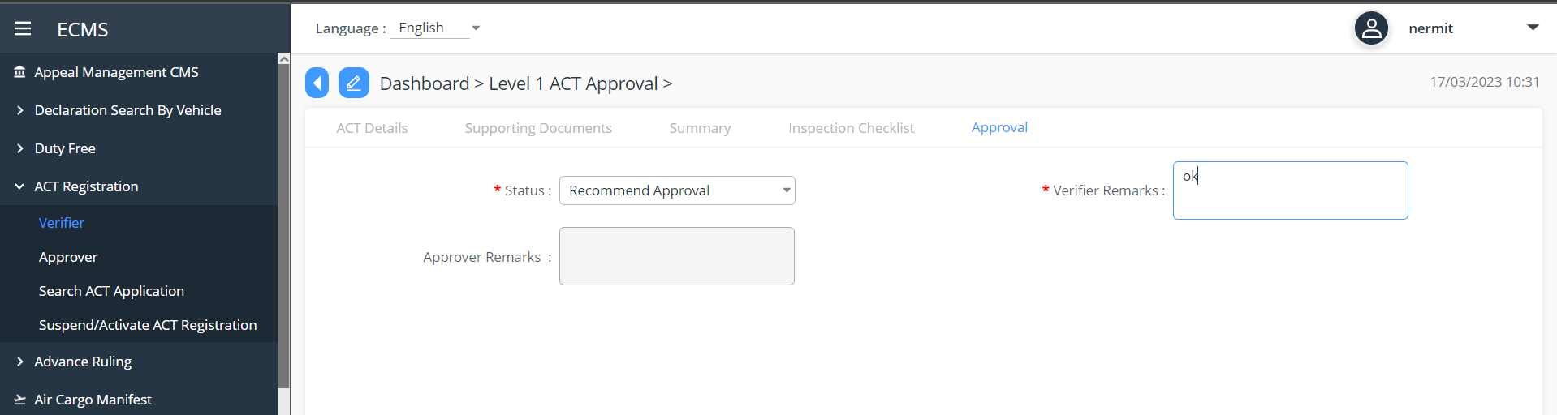

Assessor: Level 2
- If the application has been recommended for ACT by the verifier, System will assign the application to the work queue of an Assessor at the Customs head office.
- If the assessor determines that the application needs to be rejected for any reason, then the assessor will reject the application and provide reasons for rejection. eCMS will notify the applicant of the rejection.
- During assessment, if the Assessor concludes that the provided documents and related details are in order, then the Assessor can approve the application for ACT certification. In this case, System will certify the applicant as an ACT in eCMS.
- Applicable fees are configured in the System,
- If no fees are applicable, system will allow printing of certificate of registration.
- If fees are applicable, a payment advice shall be generated and sent to Revenue SYSTEM
- Revenue system will send a payment confirmation to eCMS after collecting payment in Revenue system.
- After receipt of collection message, eCMS will enable printing of “Authorized Compliant Registration certificate” and ACT certification will be restored.
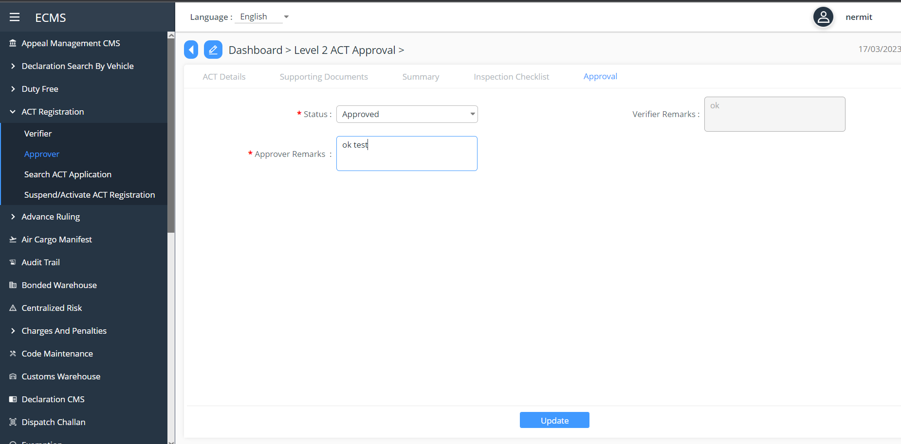

Exemption
Exemptions can be applied for specific items and for a specific reason (for example, for setting up a Manufacturing unit etc).
An FE user can apply for exemption in eCMS after logging into eCMS
- An FE user will login to eCMS and prepare an application for Import Exemption. In case of a CFA applying exemption on behalf of the importer, User shall provide the TPN number of the Importer/exporter.
- User will provide required mandatory information for getting an exemption and submit.
- A unique number shall be generated for the track of application.

Upon submission, System will generate an application number.
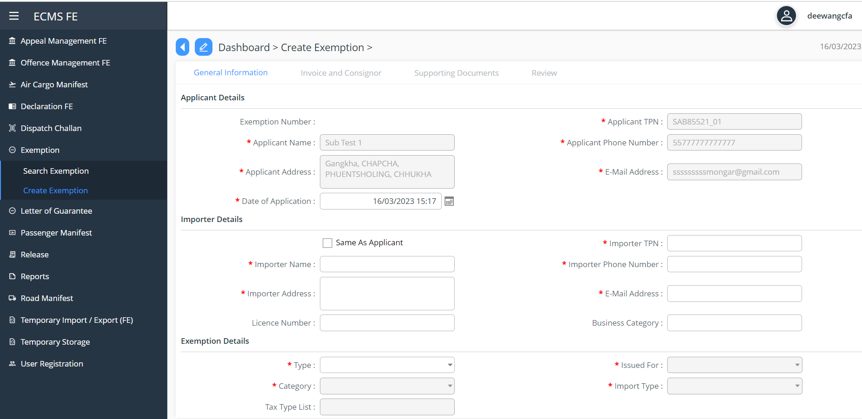
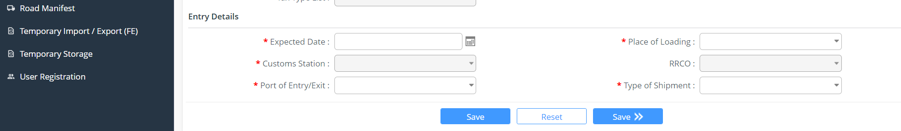

Screenshot for Exemption Creation

Verification: Level 1

When the exemption application has been submitted, System will route the application for review to the work queue of the Verifier (Custom)
- The verifier based on the review will either recommend, reject, or reject for amendment. The status of the application shall reflect the action taken by the verifier.
- During verification, if the verifier concludes that the application is invalid for any reason, then the Verifier will provide reasons for rejection and reject the application. The applicant shall be notified of the rejection including the reason for rejection by email.
- Amendment: if the documents submitted are incomplete or the application needs further amendment, the same will be reverted to the applicant for amendment

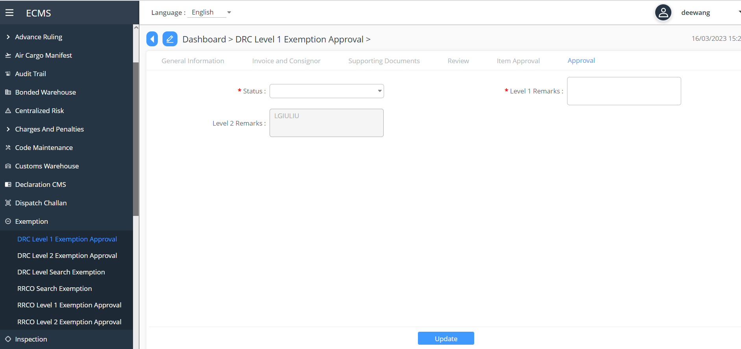
Screenshot for Level 1 Exemption Approval (by Verifier)

Level 2 Approval
      - If the exemption has been verified and recommended by the verifier, System will route the application for review to the work queue of an Assessor at the Customs Head Office.
      - Assessor will check recommended application detail and determine if it can be approved. If the assessor determines that the application needs to be rejected for any reason, then the assessor will reject the application and provide reasons for rejection. eCMS will notify the applicant of the rejection by email.

      - The application can be reverted to the verifier for further review too by the assessor.

      - If the application is approved, the applicant must be issued an Import Duty Exemption Certificate (IDEC), which must be allocated a unique system generated reference number and will be valid for one (1) year.

      - System will notify the applicant on the approval of the Exemption request. System will allow applicant to print the exemption from the system.
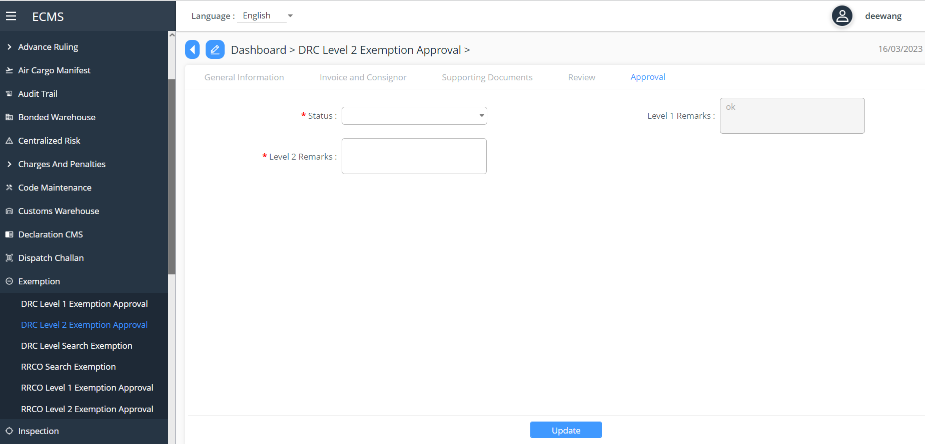

Screenshot for Level 2 Exemption Approval (by Assessor)

Duty Free Quota
An external user can apply for Duty-Free Quota in eCMS. The application will be made available in the public portal and will not require the user to login to eCMS.

For applicant:
- The system shall allow the applicant to key in CID. If the applicant keys in the CID, the same should hit the eCMS PIN Master, and list all the TPN registered against the CID.
- For the selected TPN, System will fetch the related TPN details and display in the application. For duty free quota, only individual shall be allowed (No Business or Company TPN)

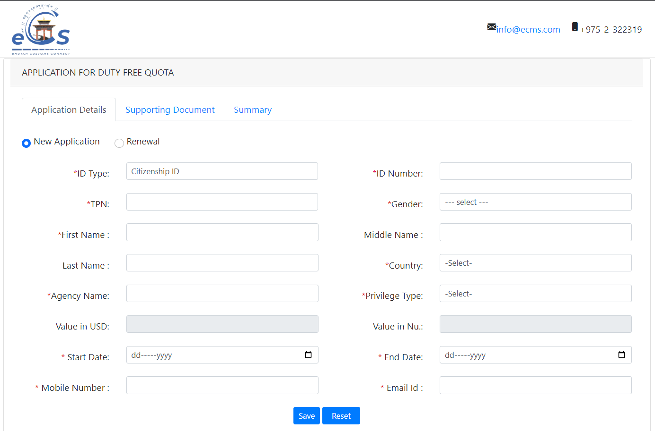
Screenshot for Duty Free Membership Application

Verify Application

- When the duty-free quota application has been submitted, System will route the application for review to the work queue of a Verifier at the Head Office.

- During verification, if the verifier concludes that the application is invalid for any reason, then the Verifier will provide reasons for rejection and reject the application. The applicant shall be notified of the rejection including the reason for rejection by email.

- Amendment: if the documents submitted are incomplete or the applicant need further amendment, the same will be reverted to the applicant for amendment by email.

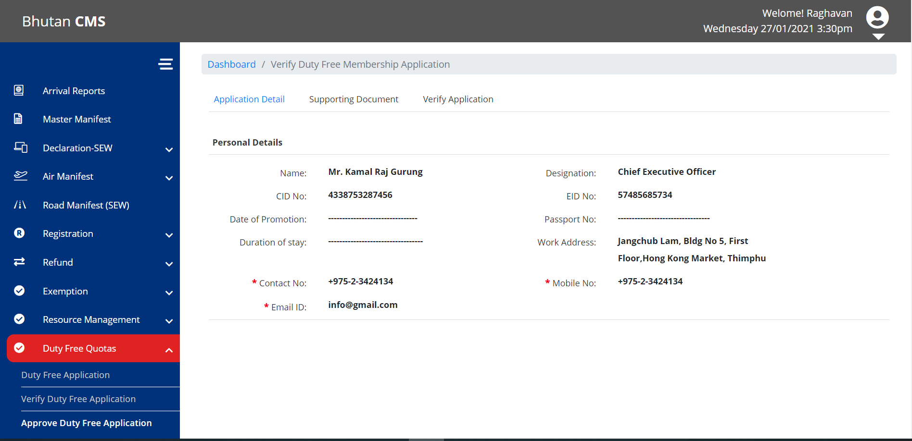
Screenshot for Verification of DutyFree Membership Application (by Verifier)

Approve Duty Free Application
- If the Duty-Free Quota has been verified and recommended by the verifier, System will route the application to the work queue of an Assessor at the Customs Head Office.
- Assessor will check recommended application detail and determine if it can be approved. If the assessor determines that the application needs to be rejected for any reason, then the assessor will reject the application and provide reasons for rejection. eCMS will notify the applicant of the rejection.

- If the application is approved, System will generate an approval letter with a unique system generated Quota number which shall be valid till 31st Dec of the approval year based on date of approval.

- System will notify the applicant on the approval of the Duty-Free Quota request and include the Quota details as well.
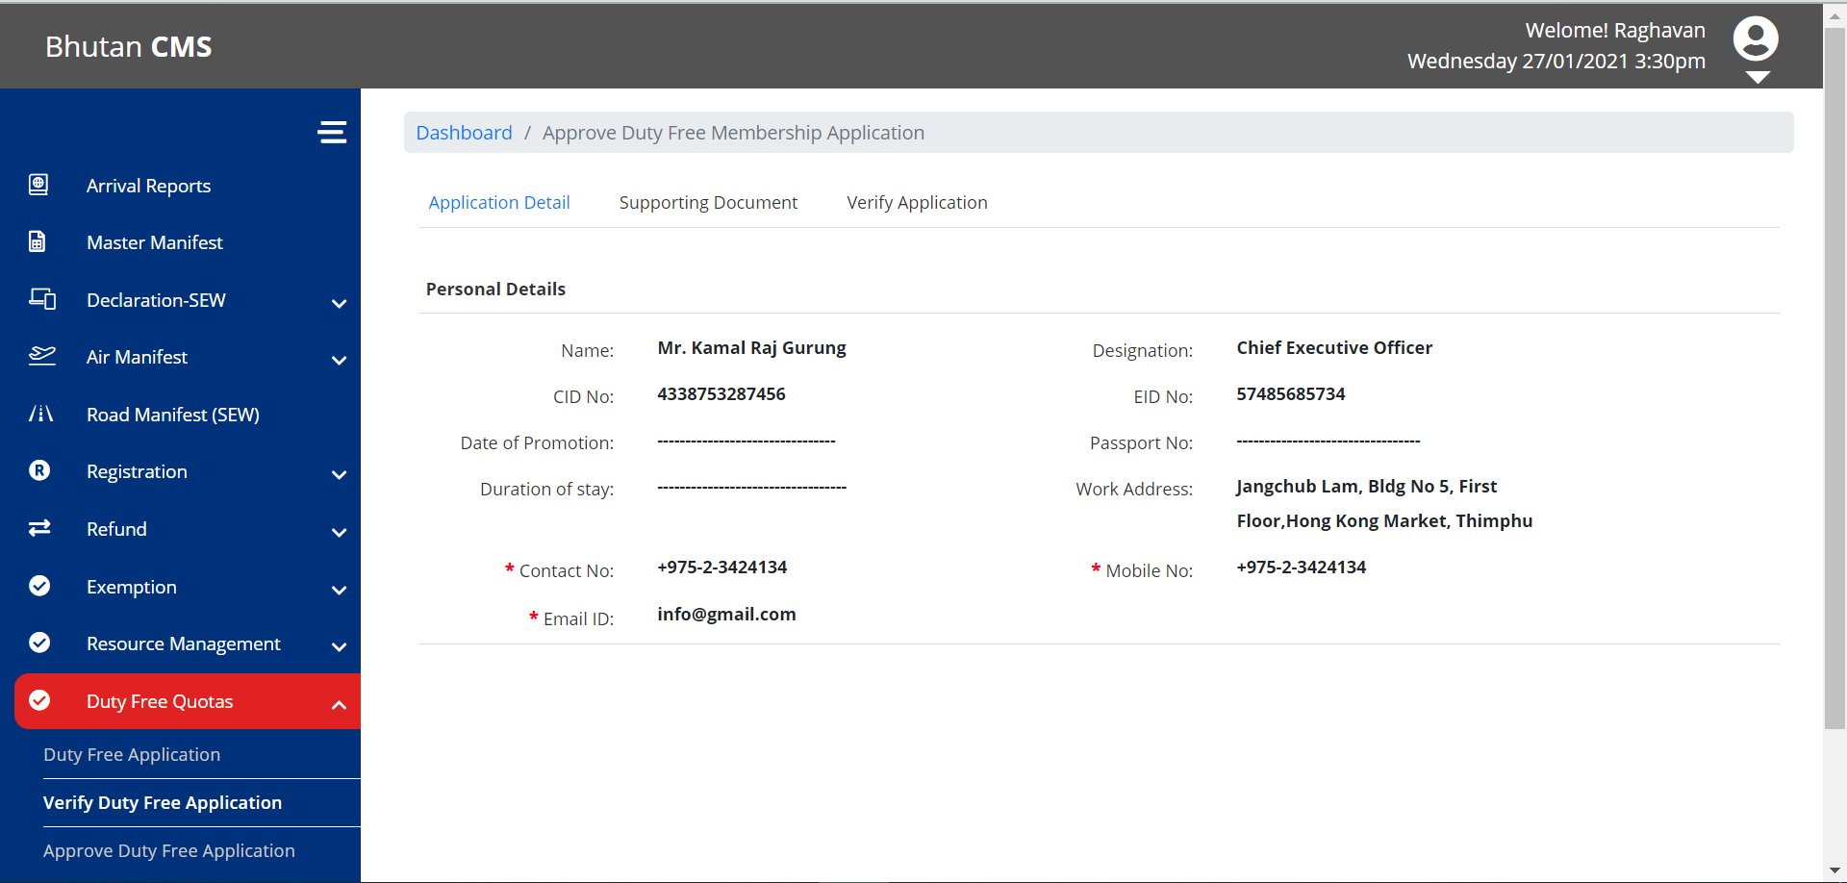
Screenshot for Duty Free Application Approval (by Assessor)

CFA Authorization
A Trader will need to authorize a CFA to act on its behalf and transact in eCMS as its representative. For this, the Trader will need to apply from the Portal (outside Login) and indicate the CFA to be authorized. Upon submission, the application shall be reviewed and approved by a Verifier at the Customs Head office. Post approval from Customs, the CFA can act on behalf of the Trader and submit declarations and other trade related documents in the System.

Application.
- The system will allow the applicant to key in CID as well as TPN. The system will validate the keyed in CID and the TPN and accordingly allow the applicant to process further. In case of a business, the system will allow to key in the business license no and the TPN.
- If the TPN belongs to a Company, then the Applicant will be required to provide the Company registration number for authentication, the system will validate the keyed in TPN and the company registration number and accordingly allow the applicant to proceed to fetch the TPN details and display in the Application.
- If the keyed in details is validated then System will fetch the related TPN details and display in the application (in case the TPN belongs to a Company, then system will follow authentication using Company registration number as mentioned in Step 2 before displaying TPN details).

After providing a valid TPN, Trader shall indicate the CFA which needs to be authorized from a list of registered and active CFA’s in eCMS and proceed to submit the application for authorizing the selected CFA. Only one CFA per application can be indicated.

The system will also allow the applicant to select the start date and end date. (validity of the authorization)

Application can be for:
      - CFA Authorization
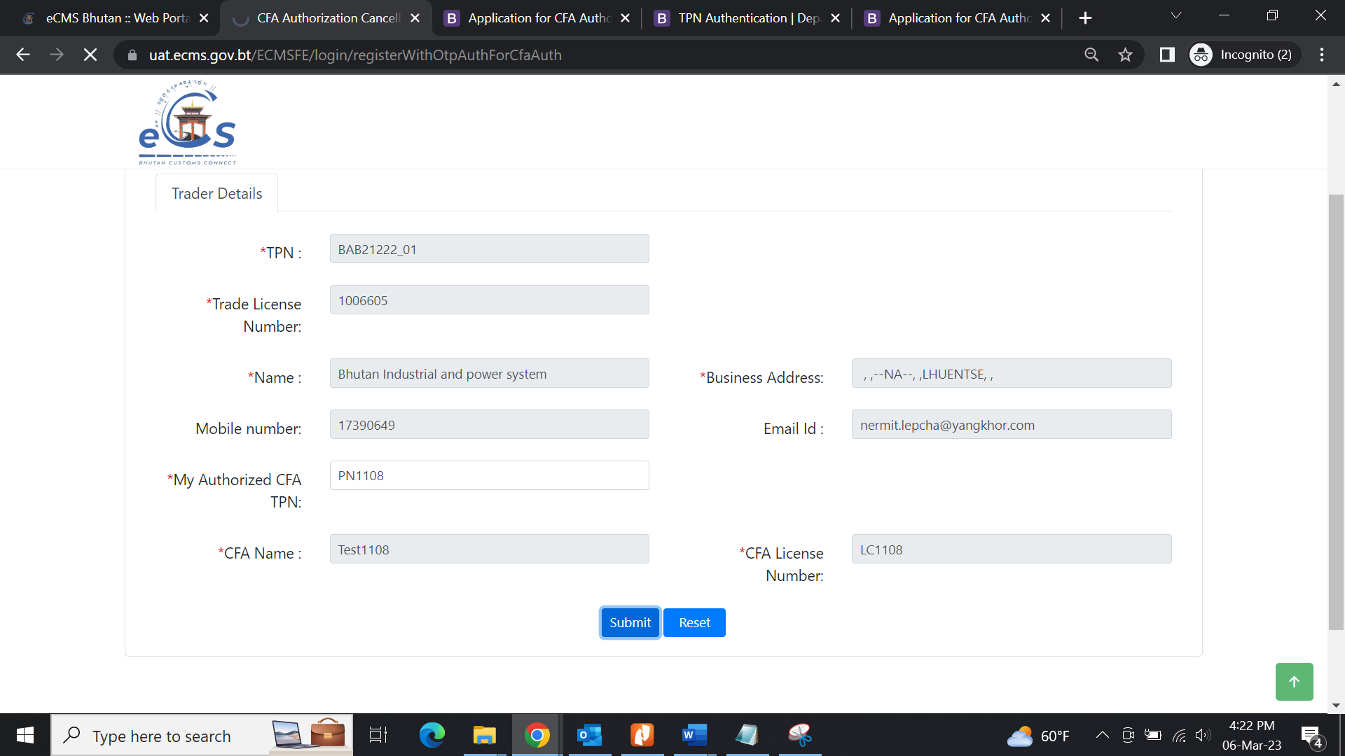

Verification Level 1
- System will assign the application to the work queue of a Verifier at the Customs head office
- The verifier will verify the applicant details and determine the validity of the application. The verifier based on the review will either approve or reject the application.
- During verification, if the verifier concludes that the application is invalid for any reason, then the Verifier will provide reasons for rejection and reject the application. The applicant shall be notified of the rejection including the reason for rejection by email.

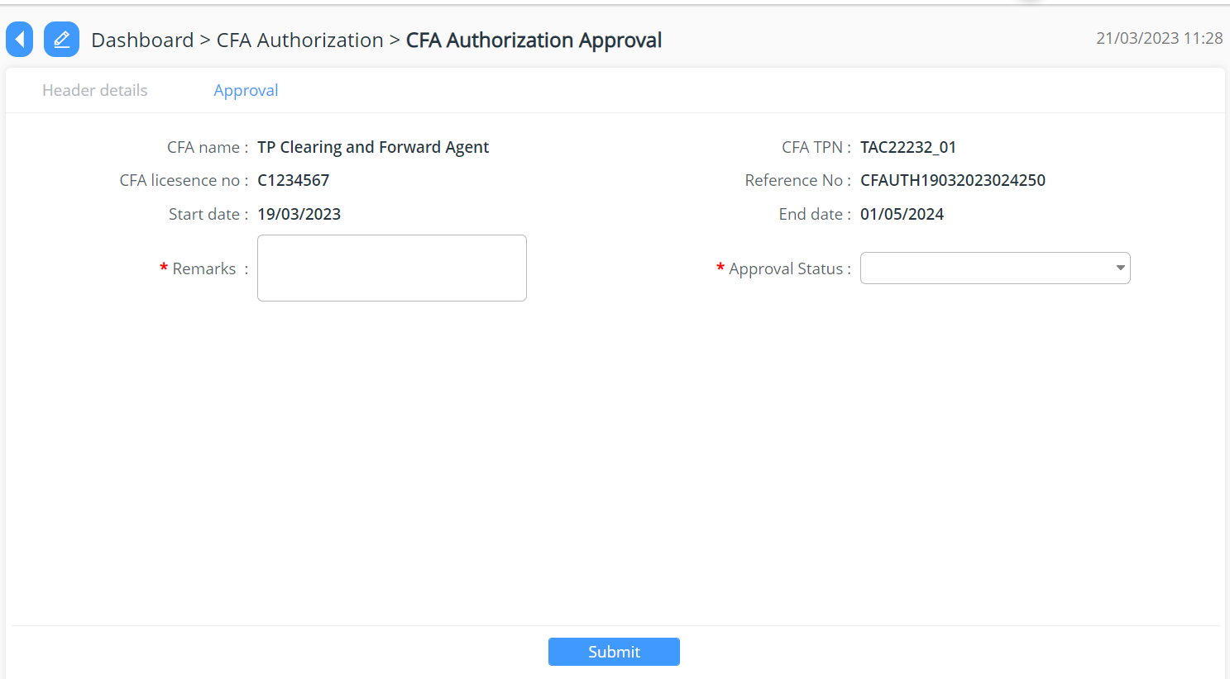

Screenshot CFA approver from Cust end

Approve Authorization
During verification, if the Verifier concludes that the provided details are in order, then the Verifier can approve the Authorization. In this case, System will authorize the CFA to act on behalf of the Trader.
After approval, System will send a notification to the Trader and the CFA.

CFA De-authorization

Dependency Viewpoint
The Dependency Viewpoint refers to the interconnection of classes that have a common goal.
The Application Module uses quite a few classes that shares information and parameters among themselves. The Package Diagram for the Application Module, shown below, demonstrates that.

logging
ORM
data
business
web
Application Controller
Config
exception
Application Service
Config
exception
servicehelpers
ApplicationDAO
Config
exception
daohelpers
mysql-connector.jar
MySQL JDBC Driver
datasource
type
data
values
System Database Schema

In the diagram, following dependencies between different packages are shown:
- web package is dependent on the business package,
- business package depend on the data package and
- ORM package depend on the data package.

These dependencies are explained below:

The Web package of Application Module contains the ApplicationController class that reads configuration information from a config file and uses the Application Service class from the business package to delegate responsibilities. This Application Service class also gets its configuration information from a different config file and uses service helpers class for doing the business logic processing and Application DAO class from ORM package for achieving db-centric activities. The service helpers class provides business and data access logic with distributed transaction supports. The Application DAO class performs the assigned responsibilities depending on dao helpers class and reads a third config file to do so. The dao helpers class accesses the data from the database using a data source. The data source depends on the database driver (mysql-connector.jar), which is supplied externally. The data available in the data package is associated with type and values. All of the dao helpers class from ORM package, the service helpers class from business package and the Application Controller class from the web package may throw different exception classes at different points of time, which are redirected to the external logging sub-system. This logging sub-system is used for analyzing the flow of control of the application.

ER Diagram

(Exemption ER Diagram)
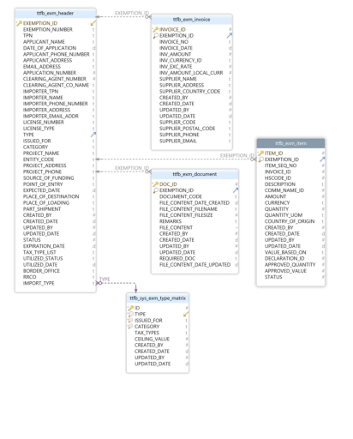

Table Name | Purpose
tfb_exm_header | <Purpose of the table>
tfb_exm_invoice
tfb_exm_item
tfb_exm_document

Field Details :

Authorized Compliance Trader (ACT) Er diagram
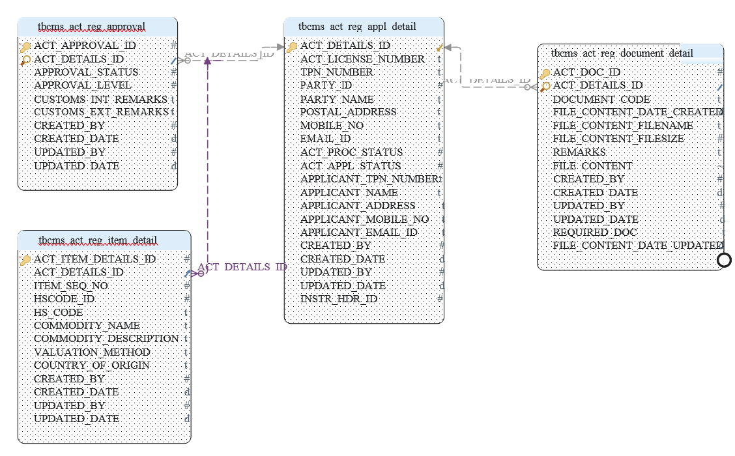

Table tbcms_act_reg_appl_detail:

* Pk | ACT_DETAILS_ID | INT
 | ACT_LICENSE_NUMBER | VARCHAR(35)
 | TPN_NUMBER | VARCHAR(35)
 | PARTY_ID | DECIMAL(5,0)
 | PARTY_NAME | VARCHAR(100)
 | POSTAL_ADDRESS | VARCHAR(100)
 | MOBILE_NO | VARCHAR(50)
 | EMAIL_ID | VARCHAR(100)
 | ACT_PROC_STATUS | DECIMAL(15,0)
 | ACT_APPL_STATUS | DECIMAL(15,0)
 | APPLICANT_TPN_NUMBER | VARCHAR(35)
 | APPLICANT_NAME | VARCHAR(70)
 | APPLICANT_ADDRESS | VARCHAR(100)
 | APPLICANT_MOBILE_NO | VARCHAR(50)
 | APPLICANT_EMAIL_ID | VARCHAR(100)
 | CREATED_BY | DECIMAL(15,0)
 | CREATED_DATE | TIMESTAMP(6)
 | UPDATED_BY | DECIMAL(15,0)
 | UPDATED_DATE | TIMESTAMP(6)
 | INSTR_HDR_ID | DECIMAL(5,0)

Table tbcms_act_reg_approval
* Pk | ACT_APPROVAL_ID | INT
Idx | ACT_DETAILS_ID | INT
 | APPROVAL_STATUS | DECIMAL(15,0)
 | APPROVAL_LEVEL | INT
 | CUSTOMS_INT_REMARKS | VARCHAR(512)
 | CUSTOMS_EXT_REMARKS | VARCHAR(512)
 | CREATED_BY | DECIMAL(15,0)
 | CREATED_DATE | DATE
 | UPDATED_BY | DECIMAL(15,0)
 | UPDATED_DATE | TIMESTAMP(6)

Table tbcms_act_reg_document_detail
* Pk | ACT_DOC_ID | INT
Idx | ACT_DETAILS_ID | INT
 | DOCUMENT_CODE | VARCHAR(3)
 | FILE_CONTENT_DATE_CREATED | DATE
 | FILE_CONTENT_FILENAME | VARCHAR(300)
 | FILE_CONTENT_FILESIZE | INT
 | REMARKS | VARCHAR(256)
 | FILE_CONTENT | LONGBLOB
 | CREATED_BY | DECIMAL(15,0)
 | CREATED_DATE | TIMESTAMP(6)
 | UPDATED_BY | DECIMAL(15,0)
 | UPDATED_DATE | TIMESTAMP(6)
 | REQUIRED_DOC | VARCHAR(5)
 | FILE_CONTENT_DATE_UPDATED | TIMESTAMP(6)

Table tbcms_act_reg_item_detail

* Pk | ACT_DOC_ID | INT
Idx | ACT_DETAILS_ID | INT
 | DOCUMENT_CODE | VARCHAR(3)
 | FILE_CONTENT_DATE_CREATED | DATE
 | FILE_CONTENT_FILENAME | VARCHAR(300)
 | FILE_CONTENT_FILESIZE | INT
 | REMARKS | VARCHAR(256)
 | FILE_CONTENT | LONGBLOB
 | CREATED_BY | DECIMAL(15,0)
 | CREATED_DATE | TIMESTAMP(6)
 | UPDATED_BY | DECIMAL(15,0)
 | UPDATED_DATE | TIMESTAMP(6)
 | REQUIRED_DOC | VARCHAR(5)
 | FILE_CONTENT_DATE_UPDATED | TIMESTAMP(6)

Duty Free Quota er diagram
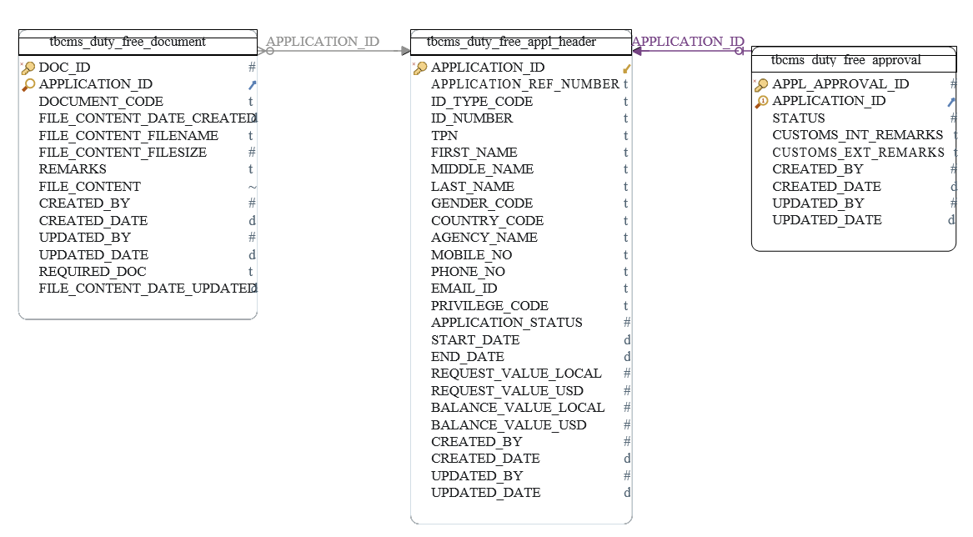
Table tbcms_duty_free_appl_header
PK | Application_ID | INT
 | APPLICATION_REF_NUMBER | VARCHAR (35)
 | ID_TYPE_CODE | VARCHAR (15)
 | IC_NUMBER | VARCHAR (35)
 | TPN | VARCHAR (35)
 | FIRST_NAME | VARCHAR (35)
 | MIDDLE_NAME | VARCHAR (35)
 | LAST_NAME | VARCHAR (35)
 | GENDER_CODE | VARCHAR (15)
 | COUNTYR_CODE | VARCHAR (35)
 | AGENCY_NAME | VARCHAR (35)
 | MOBILE_NO | VARCHAR (35)
 | PHONE_NO | VARCHAR (35)
 | EMAIL_ID | VARCHAR (35)
 | PRIVILAGE_CODE | VARCHAR (35)
 | APPLICATION_STATUS | DECIMAL (15,0)
 | START_DATE | DATE
 | END_DATE | DATE
 | REQUEST_VALUE_LOCAL | DECIMAL (22,2)
 | REQUEST_VALUE_USD | DECIMAL (22,2)
 | BALANCE_VALUE_LOCAL | DECIMAL (22,2)
 | BALANCE_VALUE_USD | DECIMAL (22,2)
 | CREATED_BY | DECIMAL (22,0)
 | CREATED_DATE | TIMESTAMP
 | UPDATED_BY | DECIMAL (22,0)
 | UPDATED_DATE | TIMESTAMP
Table tbcms_duty_free_approval
PK | APPL_APPROVAL_ID | INT
unq | APPLICATION_ID | INT
 | STATUS | INT
 | CUSTOMS_INT_REMARKS | VARCHAR (512)
 | CUSTOMS_EXT_REMARKS | VARCHAR (512)
 | CREATED_BY | DECIMAL (15,0)
Table tbcms_duty_free_approval
 | CREATED_BY | TIMESTAMP (6)
 | UPDATED_BY | DECIMAL (15,0)
 | UPDATED DATE | TIMESSTAMP (6)

Table tbcms_duty_free_document

PK | DOC_ID | INT
 | APPLICATION_ID | INT
 | DOCUMENT_CODE | VARCHAR (3)
 | FILE_CONTENT_DATE_CREATED | DATE
 | FILE_CONTENT_FILENAME | VARCHAR (300)
 | FILE_CONTENT_FILESIZE | INT
 | REMARKS | VARCHAR (256)
 | FILE_CONTENT | LONGBLOB
 | CREATED_BY | INT
 | CREATED_DATE | DATE
 | UPDATED_BY | INT
 | UPDATED_DATE | DATE
 | REQUIRED_DOC | VARCHAR (5)
 | FILE_CONTENT_DATE_UPLOADED | DATE

CFA Authorization ER diagram

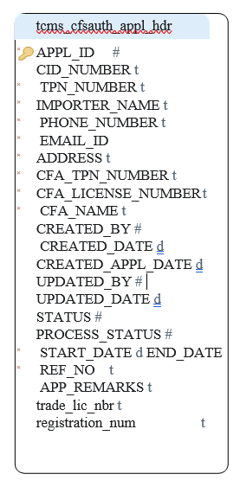
Table tcms_cfsauth_appl_hdr
PK | APP_ID | INT
 | CID_NUMBER | VARCHAR (35)
 | TPN_NUMBER | VARCHAR (35)
 | IMPORTER_NAME | VARCHAR (100)
 | PHONE_NUMBER | VARCHAR (50)
 | EMAIL_ID | VARCHAR (100)
 | ADDRESS | VARCHAR (512)
 | CFA_TPN_NUMBER | VARCHAR (35)
 | CFA_LICENSE_NUMBER | VARCHAR (100)
 | CFA_NAME | VARCHAR (50)
 | CREATED_BY | DECIMAL (22,0)
 | CREATED_DATE | TIMESTAMP
 | CREATED_APPL_DATE | TIMESTAMP
 | UPDATED_BY | DECIMAL (22,0)
 | UPDATED_DATE | TIMESTAMP
 | STATUS | DECIMAL (22,0)
 | PROCESS_STATUS | DECIMAL (22,0)
 | START_DATE | TIMESTAMP
 | END_DATE | VARCHAR (50)
 | APP_REMARK | VARCHAR (255)
 | TRADE_LIC_NBR | VARCHAR (35)
 | REGISTRATION_NUM | VARCHAR (50)

